**Title: If Denmark were Sweden: past losses and future gains in lifespan and lifespan inequality by cause and age.**

**Authors:** José Manuel Aburto a*, Maarten Wensink a*, Alyson van Raalte b & Rune Lindahl-Jacobsen a

**Author affiliations:**

a Institute of Public Health- Unit of Biodemography, University of Southern Denmark, Odense 5000, Denmark.

b Max Planck Institute for Demographic Research, Rostock 18057, Germany

* These authors contributed equally to the paper

**Corresponding authors:** José Manuel Aburto & Maarten Wensink

**Classification:** Epidemiology, Public Health, Demography

**Keywords:** Demography, lifespan variability, aging, mortality, cause of death

**Abstract [250 words]**

***Background*** Increasing life expectancy and lifespan equality are important health policy goals. Danish life expectancy stagnated between 1975 and 1995 for females and progressed slowly for males. It still lags that in Sweden and Norway for both sexes. It is unknown how this is for lifespan inequality and which causes and ages have driven these developments.

***Methods*** Cause-by-age decomposition techniques were used to analyze changes in Danish life expectancy and lifespan inequality from 1960 to 2014, and of current Swedish-Danish differences.

***Results*** Stagnation in Danish life expectancy coincided with a shorter period of stagnation in lifespan inequality (1975-1990). The stagnation in life expectancy was mainly driven by increases in cancer and non-infectious respiratory mortality at higher ages offsetting a reduction in cardiovascular and infant mortality. Lifespan inequality stagnated because most causes of death did not show compression over the time period. Both these observations were consistent with higher smoking related mortality in the interwar cohorts. After 1995 life expectancy and lifespan equality increased in lockstep, but still lag those of Sweden mainly due to infant mortality and cancer.

***Conclusions*** In Denmark since 1960, improvements in life expectancy and lifespan equality were held back by smoking related mortality in the interwar cohorts, while also reductions in old-age cardiovascular mortality held back lifespan equality. The comparison with Sweden suggests that Denmark can now reduce inequality in lifespan and increase life expectancy through a consistent policy target: reducing cancer and infant mortality.

**Key messages**

1. Lifespan inequality is an important metric of population health that reflects heterogeneity in ages at death at the population level and uncertainty in the timing of death at the individual level.
2. The 1975-1995 stagnation in Danish female life expectancy was accompanied by a 1975-1990 stagnation in lifespan inequality. Both were consistent with high smoking related mortality in the interwar cohorts.
3. Cancer mortality is the biggest contributor to the contemporary Danish-Swedish life expectancy difference while infant mortality is the biggest contributor to the 2014 Danish-Swedish lifespan inequality difference.
4. Denmark can now reduce inequality in lifespan and increase life expectancy through a consistent policy target: reducing cancer and infant mortality.

**Introduction [~**3000 words, we have 2750ish**]**

Life expectancy is the most commonly used measure of the health status of a population and the performance of the healthcare system (1). Another important dimension is the uncertainty around that expectation: lifespan inequality (2). Lifespan inequality has become relevant for policy makers with the growing interest in economic and health inequalities (3, 4), in particular because: (1) it is a marker of heterogeneity in age at death at the macro level, and (2) it is a marker of uncertainty in the timing of death at the micro level. (5-7). Typically, early deaths are more common in underprivileged groups, simultaneously reducing life expectancy and increasing lifespan inequality (8-11). Both indicators may have implications for individuals’ decisions over their life course. For instance, when to invest in education or when to retire are decisions based on life expectancy but also on the uncertainty surrounding the eventual time of death (10).

Life expectancy is lower in Denmark than in Norway and Sweden for females and males. From 1975 to 1995, while their Scandinavian counterparts showed continuous improvement, life expectancy stagnated among Danish women, while Danish men experienced only slow progress. For both sexes, life expectancy improved after 1995, but remains lower than in Sweden and Norway (12). Differences between Denmark and Sweden in life expectancy have been thoroughly documented (13, 14). Among females, the stagnation in life expectancy resulted mainly from the increased mortality of those born from 1919 to 1939, cohorts with high levels of smoking and alcohol consumption compared to their Swedish contemporaries (13, 14). Similarly, smoking-related mortality was considerably higher in Danish compared to Swedish males because of the widespread use of snus instead of cigarettes in Sweden (15). While these differences were a known contributor to life expectancy differences (ref – Drefahl “falling behind” PLoS One), it is unclear what effect that might have had on lifespan inequality differences. Previous evidence has shown mixed results for the effects of smoking on lifespan inequality: little to no effect on the Finnish population (16), while it increased lifespan inequality in some European countries (17).

The Danish case, juxtaposed with its Scandinavian counterparts, is interesting given the shared history, culture and similarities in their healthcare systems (18). It is unknown how the different age and cause-of-death mortality trends in the three countries would extend to lifespan inequality patterns.

Because life expectancy and lifespan inequality tend to be positively correlated (5, 7) we hypothesize that 1) Denmark has higher lifespan inequality relative to Sweden and Norway in females and males; 2) the stagnation in life expectancy of Danish women was accompanied by a stagnation in lifespan inequality; 3) the slow increase in life expectancy for males was accompanied by slow reduction of lifespan inequality. Because it is well-documented that smoking in the interwar Danish female cohorts was a major cause of the 1975-1995 stagnation in Danish female life expectancy (14), we hypothesize that 4) any 1975-1995 stagnation in lifespan inequality can also be attributed to smoking related deaths in the interwar cohorts.

Hence, we analyze data since 1960 for Denmark, Sweden and Norway to make a cause-by-age analysis of changes in life expectancy and lifespan inequality for both sexes. In addition, we provide age- and cause-specific needed interventions for Denmark to reduce lifespan inequality, and translate them into gains in life expectancy towards Swedish levels in both sexes.

**Data and Methods**

***Mortality and cause of death data***

Period lifetables from age 0 to 110+ and with one-year age intervals were retrieved from the Human Mortality Database (12) for Denmark, Sweden and Norway for the period 1960 to 2014. The lifetable measures included the age-at-death distribution, survival function and life expectancy, by age and sex. Cause-of-death data were taken from the WHO Mortality Database to compute the proportion of deaths by cause, age, and sex in a given year (19). Cause-of-death data are available in 5-year age and single year categories. To increase the accuracy of the resulting estimates (20), causes of death were ungrouped into single years of age using efficient estimation of smooth distributions (21).

***Cause-of-death classification***

Data on causes of death were classified using the seventh, eighth, ninth and tenth revisions of the International Classification of Diseases (ICD) for the period studied (22). Deaths were grouped in seven major cause-of-death categories aimed at capturing conditions that might have affected mortality in these countries. We considered that smoking prevalence was comparatively high among women (and still remains high) in Denmark (14, 23); that the cardiovascular revolution took place during the studied period (24); and that the management of infectious diseases has improved greatly over the past half century (25). Hence, we grouped causes of death as follows: 1) Cancers sensitive to smoking, 2) Cancers not sensitive to smoking, 3) Cardiovascular diseases, 4) Non-infectious respiratory diseases, 5) Infectious respiratory diseases, 6) External causes and 7) Rest of causes. For ICD codes and details on the classification see Supplementary Table 1. Causes of death above age 85 were not decomposed, because of lower reliability in the presence of multi-morbidities (26). Our groupings over the various ICD revisions were cross-checked with other coding practices across ICD versions in the literature (27). We also checked for discontinuities in death counts for each of the seven causes of death at those years were ICD versions were changed.

***Lifespan inequality measure***

Several dispersion measures have been proposed to analyze lifespan inequality (28). Here, we use the coefficient of variation (CoV), which is the standard deviation divided by the mean of the lifetable age-at-death distribution, i.e. life expectancy (Supplementary Section 1 for a brief description). CoV has been found to be a good indicator to measure lifespan inequality (29). The strong correlation between dispersion indicators suggests that main conclusions and results would not differ regardless of the measure used (28, 30, 31). Life expectancy and lifespan inequality (CoV) were calculated for Denmark, Norway and Sweden throughout 1960-2014.

***Decomposition techniques***

Cause-by-age decompositions of the changes in lifespan and lifespan inequality in Denmark, Norway and Sweden were made from 1960 to 2014 using standard decomposition techniques (32). These decompositions allow singling out any period during those years, for instance 1975-1995[1]. We quantified the cause-by-age contributions to the current differences in life expectancy and lifespan inequality between Denmark and Sweden for females and males.

**Results**

***Trends in lifespan inequality and life expectancy 1960-2014***

The 1975-1995 stagnation in life expectancy for Danish females was accompanied by a shorter period of stagnation in lifespan inequality (Figure 1A). Swedish and Norwegian females experienced a decrease in inequality and increase in life expectancy throughout the period (Figure 1A). For males in all three countries, life expectancy increase was slow in 1960-1980, but accelerated thereafter, while the decrease in lifespan inequality was more monotonic (Figure 1B).

[Figure 1 about here]

***Decomposition of changes in life expectancy and lifespan inequality for Denmark***

Between 1960 and 1975, Danish female life expectancy increased from 74 to 77 years mainly due to reductions in infant mortality and mid- and old-age cardiovascular mortality (Figure 2). For males1, infant mortality was also reduced, but the contribution from cardiovascular diseases was absent (see Supplementary Figure 1), resulting in a small increase in life expectancy from 70.4 to 71.3 years. For both sexes, lifespan inequality was reduced mainly because of the reduction in infant mortality.

Between 1975 and 1995, Danish female life expectancy stagnated at about 77 years because a continued reduction in infant mortality and old-age cardiovascular mortality was offset by an increase in (mainly smoking-related) cancer and non-infectious respiratory mortality between ages 55 and 85 (Figure 2). Also, reduction in cardiovascular mortality was lower in Danish females relative to Danish males and Swedish females (Supplementary Figure 1 and [online](https://goo.gl/9dLNrH) app). The impact of mortality change on lifespan inequality is more complicated: at younger ages mortality reduction results in deaths being compressed into a narrower age range, reducing lifespan inequalities. At older ages mortality reduction stretches out the right tail of the age-at-death distribution, increasing lifespan inequality. Overall, improvement in lifespan inequality was low for Danish females because there was little compression of mortality for most causes. While for most ages changes in mortality due to smoking related cancer and non-infectious respiratory diseases had a zero or negative effect on lifespan inequality, there was an increase in mid-age smoking related cancer mortality and non-infectious respiratory mortality (Figure 2). For males, the reduction in lifespan inequality was larger than for females, mainly driven by a reduction in infant mortality and early-life external mortality (Supplementary Figure 1).

Between 1995 and 2014, Danish female and male life expectancy increased (from 77.8 to 82.7 and 72.7 to 78.6, respectively) due to almost all causes, particularly cardiovascular conditions, and all ages. As for lifespan inequality, for both sexes all ages and all causes up to around the life expectancy reduced inequality, while a reduction in cardiovascular mortality at ages higher than life expectancy increased inequality.

[Figure 2 about here]

***Decomposition of current differences in life expectancy and lifespan inequality between Denmark and Sweden***

Currently (2014)[2], life expectancy is higher in Sweden than in Denmark for both sexes due to almost all causes at all ages, with the major exception of external mortality being higher in Sweden than in Denmark at all ages, in particular ages 15-35 (Figure 3). Two major classes of mortality where Denmark is doing worse than Sweden could be identified. First, infant mortality is higher in Denmark than in Sweden (by a factor two). Second, mid- and old-age cancer mortality is higher in Denmark than in Sweden. Other recent years showed the same pattern (Figure 3).

For lifespan inequality, the same holds: infant mortality and mid-life cancer mortality increase Denmark’s disadvantage relative to Sweden, somewhat offset by lower external mortality between ages 15 and 35 (Figure 3). However, as may be expected considering the ages relative to life expectancy where each contribution is made, Denmark’s *life expectancy* disadvantage relative to Sweden is mainly due to mid- and high-age *cancer mortality*, while Denmark’s *lifespan inequality disadvantage* is mainly due to higher *infant mortality* (Figure 3).

[Figure 3 about here]

***Potential gains in Danish life expectancy if lifespan inequality were reduced towards Swedish levels***

Reducing mortality from cancers below age 85 would decrease the gap in lifespan inequality by 31% and 22% for females and males, respectively (Table 1). This would be translated into gains in life expectancy of 0.57 years for females and 0.66 years for males, respectively 44% and 37% of the overall gap. Reducing infant mortality (of all causes) to Swedish levels would reduce lifespan inequality by 46% for females and 49% for males. This would be translated into gains in life expectancy of .14 years for females and .16 years for males, respectively 10% and 9% of the overall gap.

Achieving Swedish levels in cardiovascular conditions would decrease the gap in lifespan inequality by almost 10% in both sexes and increase life expectancy by .2 year (Table 1). Conversely, if Sweden were to achieve the level of Danish external mortality, it would benefit by two additional months in life expectancy for both sexes (Table 1).

[Table 1 about here]

**Discussion**

In this study we find that the same causes and age groups that held back Danish life expectancy in 1975-1995, especially for females, also held back lifespan equality in the same period. This suggests important social development, but also a clear policy target. Although lifespan inequality has been reduced and life expectancy has increased since the late 1990s, Denmark still lags its Scandinavian counterparts, despite similarities in social and healthcare systems. The comparison with Sweden suggests that Denmark can now reduce inequality in lifespans and increase life expectancy through the same policy targets: cancer and infant mortality.

***Implications***

Reducing lifespan inequality cannot be the only policy goal, since this would neglect the interests of those who have already lived to ages close to, or exceeding, life expectancy: Mortality reductions at ages below ages around the life expectancy decrease lifespan inequality, but mortality reductions at ages above life expectancy increase lifespan inequality (33). Therefore, the causes that extend lifespan and the causes that reduce inequality are not necessarily the same (34). In Denmark, increases in mortality from causes of death related to smoking contributed to simultaneous stagnation in life expectancy over the 1975-1995 period. Although these causes of death did play a role on lifespan inequality over the same period, the net effect on the overall level is unclear since they occurred below and above the so-called threshold age in that period. Whereas in the most recent period, cancer related mortality has driven both the rise in life expectancy and reductions in lifespan inequality. Previous evidence suggests that this needs not to be the case among the Finnish population (16), and that causes of death that drive cross-sectional differences in lifespan inequality are not necessarily the same as the causes of death that drive contemporary gaps

After 1995, Denmark has been able to reduce inequality in lifespans in lockstep with increases with life expectancy. This has been possible because of major improvements, mainly below age 80, in cancer and cardiovascular diseases. However, it is possible that this progress may have been different by socioeconomic status (8). Moreover, there still is room for improvement, since Denmark lags Sweden in both life expectancy and lifespan inequality. The comparison with Sweden suggests that Denmark can simultaneous increase life expectancy and decrease lifespan inequality by targeting two main causes of death: cancer and infant mortality. Reducing lifespan inequality towards Sweden by these conditions would lead to an increase of 0.7 and 0.8 years in life expectancy for females and males in Denmark, respectively. To put this in perspective, in 2014 the mortality rate in the first year of life in Denmark is twice as high as in Sweden, which is one of the lowest in developed countries (12). Although mortality at very young ages may be affected by registration systems in high income countries (e.g. non-viable live births registered as stillbirths) (35), the Nordic countries does not show evidence of such pattern (36). Moreover, even after controlling for weeks of gestation, Sweden shows lower infant mortality rates than Denmark (37). Thus, infant mortality is the largest single contributor to the gap with Sweden in terms of lifespan inequality. Preventive policies focusing on prenatal risk factors and improving maternal health before and during pregnancy (38), as well as efforts to reduce the risk of sudden infant death syndrome (39) could help reducing infant mortality towards Swedish levels.

Targeting cancer is another clear public health intervention to reduce lifespan inequality and increase life expectancy in Denmark. Our results show that improvements in mortality from cancer have had an effect on both health indicators in the last 20 years. However, Denmark had the highest mortality rates from all neoplasms in the European region, and the female population exhibited the highest lung cancer mortality rates (23). This is in line with our comparison with Sweden and with previous evidence highlighting the role of smoking behaviors on life expectancy trends (14).

For Sweden, the decomposition results suggest that young-age external mortality can be further reduced. According to the WHO, males in Denmark have lower external mortality standardized rates (39 per 100,000) than Sweden and Norway (50.6 and 52 respectively) in 2014 (40). Our results further show that the differences are concentrated in ages 15 and 40. Moreover, since the late 1990s, Swedish males have experienced higher suicide rates between ages 15 and 24 (41).

Of course, the mere observation that Sweden is doing better than Denmark for most causes of death, does not mean that Denmark could easily do better. However, it does provide a starting point for public health intervention. For instance, previous evidence suggests that focusing on vulnerable and less socially advantaged subgroups may reduce suicide rates among the young (41, 42).

For other countries that lag a comparable country, similar decompositions can be made. This may not result in a clear and consistent message: causes of death that hold back life expectancy may not be the same as the causes of death that hold back equality. Yet if it does, as in the case of Denmark, the benefits are substantial, because the policy goals can be so clearly stated. We therefore suggest that this method could be a valuable tool for epidemiologists and policy makers alike.

***Strengths and limitations***

As any cause of death analysis, our study has the limitations that: 1) causes of death are treated as mutually exclusive, while they may not be (e.g., poor sight due to diabetes may lead to an accident); 2) medical doctors and even coroners have imperfect knowledge about causes of death; and 3) trends in awareness of certain diseases, and changing insights in disease processes affect classification. Yet through using otherwise high quality data and broad categories of causes of death, we believe we have achieved a useful, workable grouping of causes of death. In addition, we perform a sensitivity analysis to assure consistency of grouping across ICD versions and did not find significant variation when ICD revisions changed (Supplementary Figures 2-4).

Lifespan inequality is an important dimension of population health. By looking at this dimension we could disclose how lifespans differ within Denmark, Sweden and Norway. Moreover, our decomposition by age- and cause-of-death allowed us to identify conditions and ages that contribute the most to lifespan inequality changes, and we were able to translate them into potential gains in life expectancy if efforts were concentrated in these ages and causes of death.

**Conclusions**

Lifespan inequality together with life expectancy gives a broader perspective on the effect of mortality changes on population health. Our results show that the stagnation in

Danish life expectancy was accompanied by a stagnation in lifespan inequality, driven largely by the same smoking related causes and the same age groups. Currently, Denmark lags Sweden in terms of high life expectancy and low inequality due to two main causes: infant mortality and cancer. Denmark therefore has a clear and consistent public health policy target: reduce infant mortality and cancer mortality. Our approach demonstrates how reduction in lifespan inequality as a policy target can be translated into gains in life expectancy.

**Funding**

**Figures and Tables**

Figure 1. Life expectancy (panel A) and lifespan inequality (panel B) trends from 1960 to 2015 for Denmark, Sweden and Norway by sex. The shaded area refers to the period of life expectancy stagnation in Danish females 1975-1995.

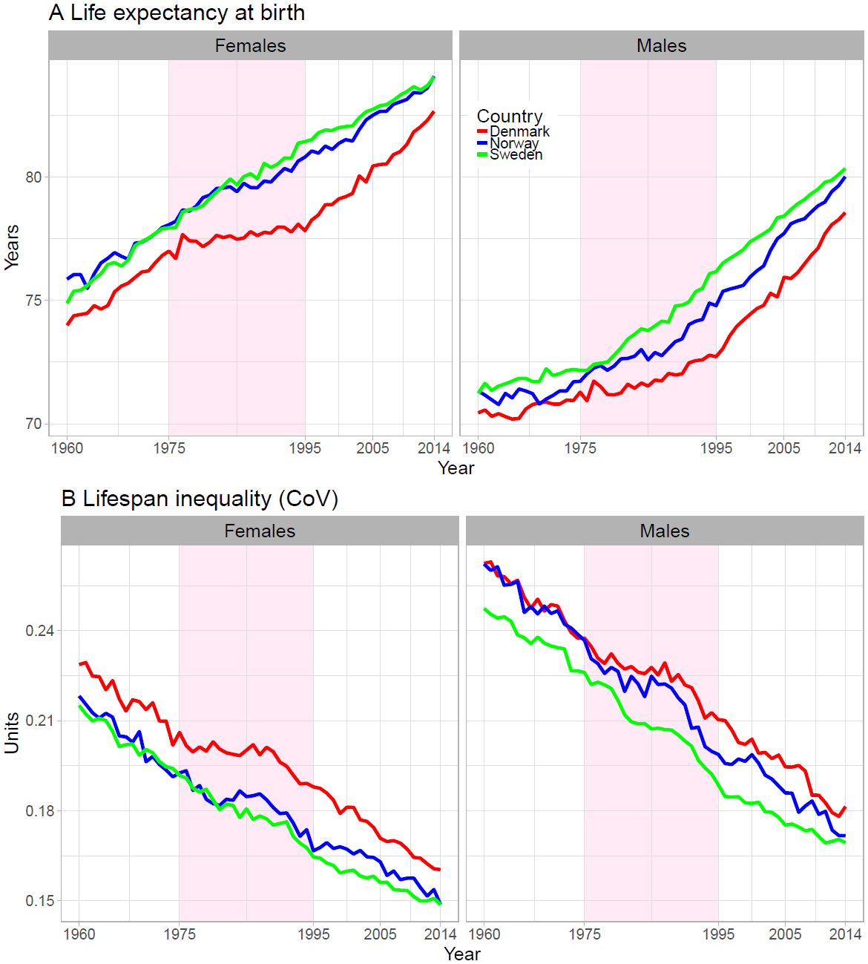

Figure 2. Age and cause contributions to changes in life expectancy (panel A) and lifespan inequality (panel B) between 1960-1975, 1975-1995 and 1995-2014 for Danish females. Note: Age 0 is truncated in panel B since it accounts for the largest contribution.

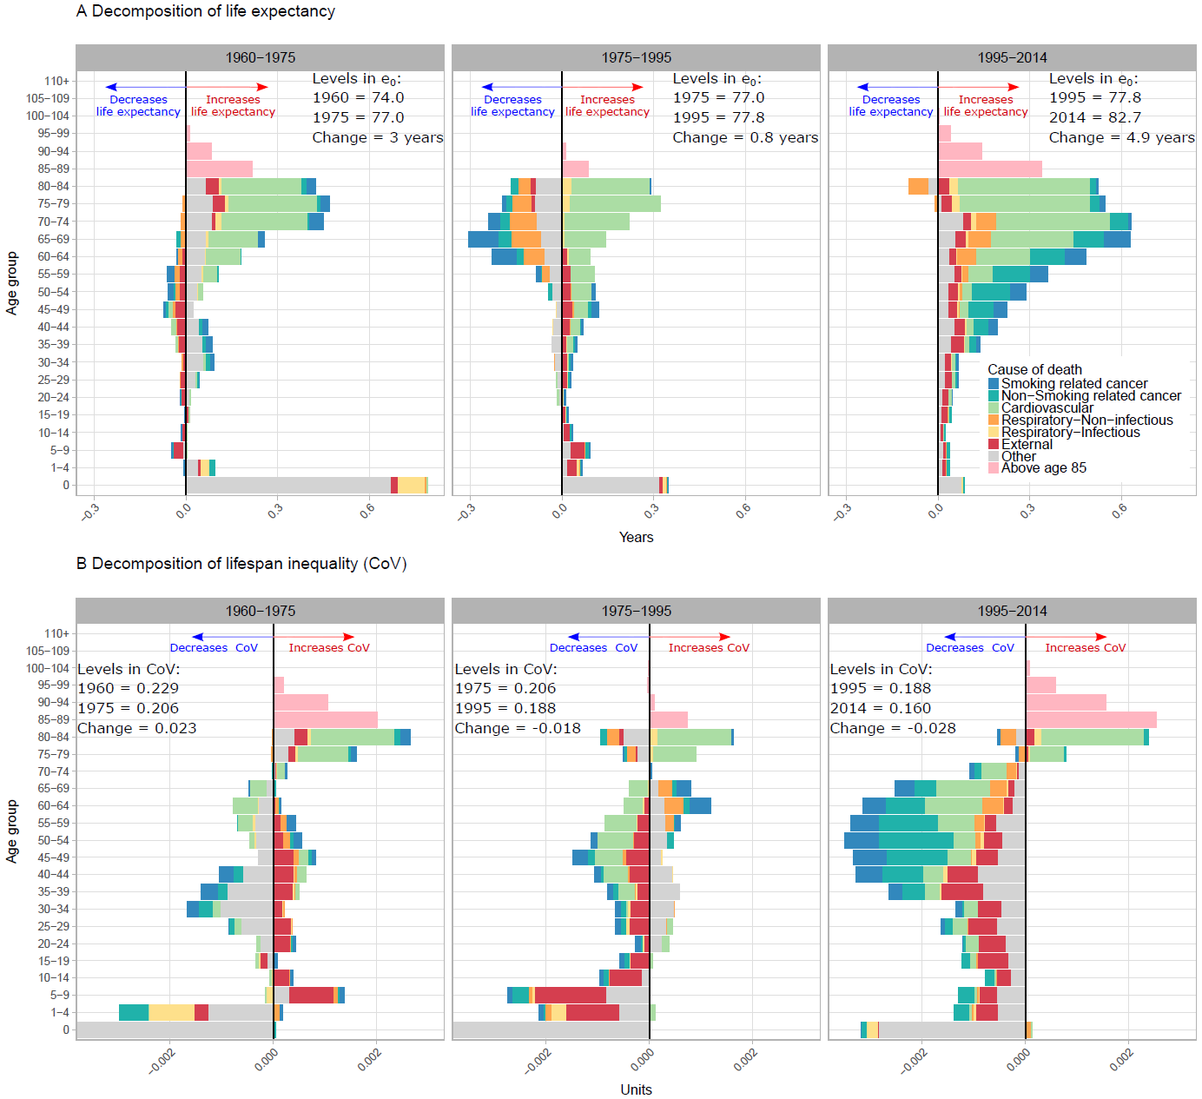

Figure 3. Age and cause contributions to the gap in life expectancy (Panel A) and lifespan inequality (Panel B) with Sweden in 2014 by sex.

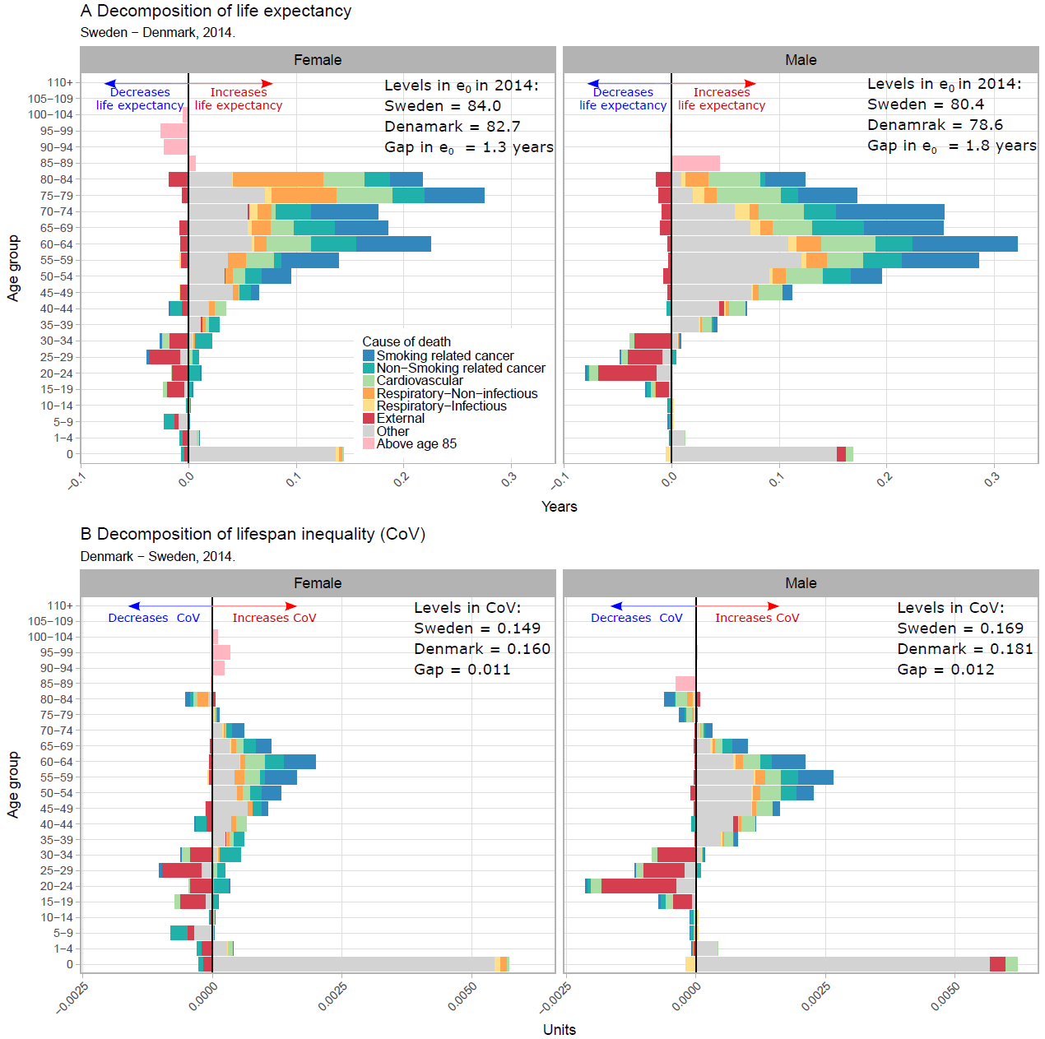

Table 1. Potential gains in life expectancy in Denmark if inequality is reduced (%) to Swedish levels in 2014 for each cause of death.

|  |  |  |  |  |  |  |  |
| --- | --- | --- | --- | --- | --- | --- | --- |
| Sex |  | Cause of death | Reduce gap with Sweden in CoV (%) |  | Reduction in life expectancy (%) |  | Potential Gains in life expectancy (years) |
| Females | 1 | Smoking related cancer | 18% |  | 25% |  | 0.35 |
|  | 2 | Non-Smoking related cancer | 13% |  | 16% |  | 0.22 |
|  | 3 | Cardiovascular | 10% |  | 15% |  | 0.21 |
|  | 4 | Respiratory-Infectious | 2% |  | 2% |  | 0.03 |
|  | 5 | Respiratory-Non-infectious | 7% |  | 17% |  | 0.23 |
|  | 6 | External | -26% | * | -11% | ** | -0.15 |
|  | 7 | Other | 71% |  | 40% |  | 0.55 |
|  | 8 | Above age 85 | 5% |  | -3% | ** | -0.05 |
|  |  |  |  |  |  |  |  |
| Males | 1 | Smoking related cancer | 15% |  | 26% |  | 0.47 |
|  | 2 | Non-Smoking related cancer | 7% |  | 10% |  | 0.19 |
|  | 3 | Cardiovascular | 10% |  | 19% |  | 0.33 |
|  | 4 | Respiratory-Infectious | 1% |  | 3% |  | 0.05 |
|  | 5 | Respiratory-Non-infectious | 5% |  | 7% |  | 0.12 |
|  | 6 | External | -26% | * | -11% | ** | -0.19 |
|  | 7 | Other | 92% |  | 43% |  | 0.77 |
|  | 8 | Above age 85 | 0.0 |  | 0.0 |  | 0.04 |
| * Increases the gap with Sweden. Represents potential gains for Sweden if they achieve the levels of Denmark. | | | | | | | |
| ** Increases the gap with Sweden in life expectancy. | | | | | | | |

**References**

1. Organization WH. World Health Statistics 2016: Monitoring Health for the SDGs Sustainable Development Goals: World Health Organization; 2016.

2. Tuljapurkar S. The final inequality. Demography and the Economy. 2011:209.

3. Marmot M. Inequalities in health. New England Journal of Medicine. 2001;345(2):134-5.

4. Mackenbach JP, Kulhánová I, Artnik B, Bopp M, Borrell C, Clemens T, et al. Changes in mortality inequalities over two decades: register based study of European countries. bmj. 2016;353:i1732.

5. Vaupel JW, Zhang Z, van Raalte AA. Life expectancy and disparity: an international comparison of life table data. BMJ open. 2011;1(1):e000128.

6. Edwards RD, Tuljapurkar S. Inequality in life spans and a new perspective on mortality convergence across industrialized countries. Population and Development Review. 2005;31(4):645-74.

7. Smits J, Monden C. Length of life inequality around the globe. Social Science & Medicine. 2009;68(6):1114-23.

8. Brønnum-Hansen H. Socially disparate trends in lifespan variation: a trend study on income and mortality based on nationwide Danish register data. BMJ open. 2017;7(5):e014489.

9. Firebaugh G, Acciai F, Noah AJ, Prather C, Nau C. Why lifespans are more variable among blacks than among whites in the United States. Demography. 2014;51(6):2025-45.

10. van Raalte AA, Kunst AE, Deboosere P, Leinsalu M, Lundberg O, Martikainen P, et al. More variation in lifespan in lower educated groups: evidence from 10 European countries. International Journal of Epidemiology. 2011:dyr146.

11. Aburto JM, van Raalte A. Lifespan dispersion in times of life expectancy fluctuation: the case of Central and Eastern Europe. MPIDR working paper. 2017.

12. Human Mortality Database. University of California BU, and Max Planck Institute for Demographic Research (Germany). Human Mortality Database. 2017.

13. Lindahl-Jacobsen R, Oeppen J, Rizzi S, Möller S, Zarulli V, Christensen K, et al. Why did Danish women’s life expectancy stagnate? The influence of interwar generations’ smoking behaviour. European Journal of Epidemiology. 2016:1-5.

14. Lindahl-Jacobsen R, Rau R, Jeune B, Canudas-Romo V, Lenart A, Christensen K, et al. Rise, stagnation, and rise of Danish women’s life expectancy. Proceedings of the National Academy of Sciences. 2016;113(15):4015-20.

15. Ramström L, Wikmans T. Mortality attributable to tobacco among men in Sweden and other European countries: an analysis of data in a WHO report. Tobacco induced diseases. 2014;12(1):14.

16. van Raalte AA, Myrskylä M, Martikainen P. The role of smoking on mortality compression: An analysis of Finnish occupational social classes, 1971-2010. Demographic Research. 2015;32:589.

17. Janssen F, Rousson V, Paccaud F. The role of smoking in changes in the survival curve: an empirical study in 10 European countries. Annals of epidemiology. 2015;25(4):243-9.

18. Magnussen J. The Scandinavian healthcare system. Medical solutions. 2009:63-8.

19. Organization WH. Health statistics and information systems 2017 [Available from: <http://www.who.int/healthinfo/mortality_data/en/>.

20. Rizzi S, Thinggaard M, Engholm G, Christensen N, Johannesen TB, Vaupel JW, et al. Comparison of non-parametric methods for ungrouping coarsely aggregated data. BMC medical research methodology. 2016;16(1):59.

21. Rizzi S, Gampe J, Eilers PH. Efficient estimation of smooth distributions from coarsely grouped data. American journal of epidemiology. 2015;182(2):138-47.

22. Organization WH. International statistical classification of diseases and related health problems: World Health Organization; 2004.

23. Hashim D, Boffetta P, La Vecchia C, Rota M, Bertuccio P, Malvezzi M, et al. The global decrease in cancer mortality: trends and disparities. Annals of Oncology. 2016;27(5):926-33.

24. Smallman-Raynor M, Phillips D. Late stages of epidemiological transition: health status in the developed world. Health & place. 1999;5(3):209-22.

25. Organization WH. The world health report 2000: health systems: improving performance: World Health Organization; 2000.

26. Rosenberg HM. Cause of death as a contemporary problem. Journal of the history of medicine and allied sciences. 1999;54(2):133-53.

27. Janssen F, Kunst AE. ICD coding changes and discontinuities in trends in cause-specific mortality in six European countries, 1950-99. Bulletin of the World Health Organization. 2004;82(12):904-13.

28. van Raalte AA, Caswell H. Perturbation analysis of indices of lifespan variability. Demography. 2013;50(5):1615-40.

29. Wrycza TF, Missov TI, Baudisch A. Quantifying the shape of aging. PloS one. 2015;10(3):e0119163.

30. Wilmoth JR, Horiuchi S. Rectangularization revisited: Variability of age at death within human populations*. Demography. 1999;36(4):475-95.

31. Colchero F, Rau R, Jones OR, Barthold JA, Conde DA, Lenart A, et al. The emergence of longevous populations. Proceedings of the National Academy of Sciences. 2016.

32. Horiuchi S, Wilmoth JR, Pletcher SD. A decomposition method based on a model of continuous change. Demography. 2008;45(4):785-801.

33. Gillespie DO, Trotter MV, Tuljapurkar SD. Divergence in age patterns of mortality change drives international divergence in lifespan inequality. Demography. 2014;51(3):1003-17.

34. Seligman B, Greenberg G, Tuljapurkar S. Equity and length of lifespan are not the same. Proceedings of the National Academy of Sciences. 2016;113(30):8420-3.

35. Blencowe H, Cousens S, Oestergaard MZ, Chou D, Moller A-B, Narwal R, et al. National, regional, and worldwide estimates of preterm birth rates in the year 2010 with time trends since 1990 for selected countries: a systematic analysis and implications. The Lancet. 2012;379(9832):2162-72.

36. Deb-Rinker P, León JA, Gilbert NL, Rouleau J, Andersen A-MN, Bjarnadóttir RI, et al. Differences in perinatal and infant mortality in high-income countries: artifacts of birth registration or evidence of true differences? BMC pediatrics. 2015;15(1):112.

37. MacDorman MF, Mathews T. Behind international rankings of infant mortality: how the United States compares with Europe: Department of Health and Human Services, Centers for Disease Control and Prevention, National Center for Health Statistics; 2009.

38. Zylbersztejn A, Gilbert R, Hardelid P, Hjern A. Why do more infants die in the UK than in Sweden? An intercountry comparison of birthweight-specific infant mortality. The Lancet. 2015;386:S83.

39. Wennergren G, Nordstrand K, Alm B, Möllborg P, Öhman A, Berlin A, et al. Updated Swedish advice on reducing the risk of sudden infant death syndrome. Acta Paediatrica. 2015;104(5):444-8.

40. Organization WH. European Health Information Gateway <https://gateway.euro.who.int/en/indicators/h2020_15-mortality-from-external-causes-males/2017> [

41. Titelman D, Oskarsson H, Wahlbeck K, Nordentoft M, Mehlum L, Jiang G-X, et al. Suicide mortality trends in the Nordic countries 1980–2009. Nordic journal of psychiatry. 2013;67(6):414-23.

42. Bergen H, Hawton K, Kapur N, Cooper J, Steeg S, Ness J, et al. Shared characteristics of suicides and other unnatural deaths following non-fatal self-harm? A multicentre study of risk factors. Psychological medicine. 2012;42(4):727-41.

1. We have created an interactive app where the reader can analyze any period he/she might be interested in for any sex. Available [online](https://goo.gl/9dLNrH) app.
2. Results for any year from 1960-2014 and for Norway vs Sweden available [online](https://goo.gl/9dLNrH).